Client VPN: Zscaler
How do you access clients AWS Network and other applications?
Via an Identity Provider (Idp) based Single-Sign-On (SSO) setup in all the AWS accounts: Frontegg, SecureAuth, Keycloak, CyberArk etc
AWS IAM roles (Cloud Administrator, Developer, DevOps Engineer etc) are integrated into Idp’s Admin Console.
You access frontegg via a URL: keycloak.companyabc.com
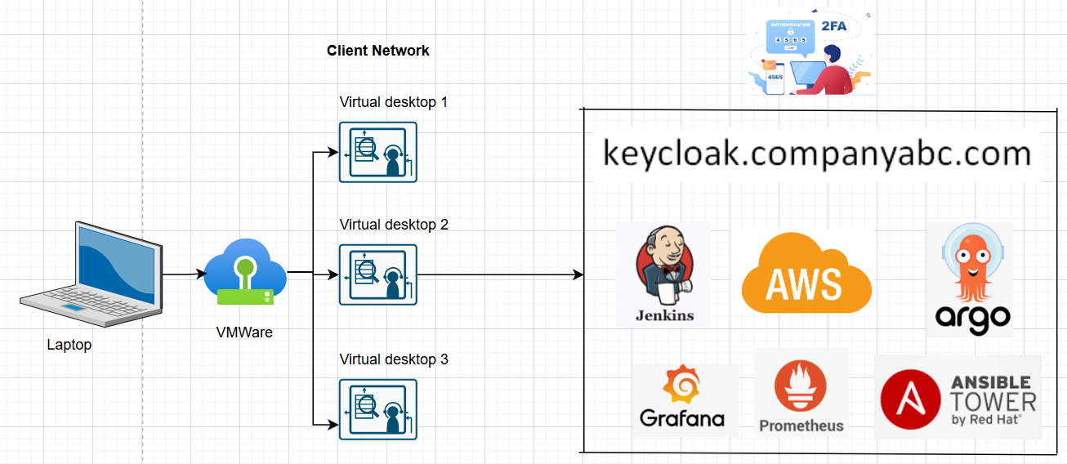

AWS’s Role Selection Screen:
